Postal Life Insurance

Department of Post

Software Requirements Specification (SRS)/ Functional Requirements Specification (FRS)
  - Billing & Collection of various PLI/RPLI receipts

INTERNAL APPROVAL FORM

Project Name: Billing & Collection of various PLI/RPLI receipts
Version: 1.0
Submitted on:
 | Name | Date
Approved By:
Reviewed By:
Prepared By:

VERSION CONTROL LOG
Version | Date | Prepared By | Remarks
1

Table of Contents

1. Executive Summary 4
2. Project Scope 4
3. Business Requirements 4
4. Functional Requirements Specification 5
DUPLICATE POLICY BOND 5
BILLING METHOD CHANGE 5
NOMINATION CHANGE 5
PREMIUM RECEIPTBOOK 5
ADDRESS CHANGE 6
NAME CHANGE 6
FREELOOK 6
COMMUTATION 6
MATURITY 7
LOAN 7
SURRENDER 7
DEATH CLAIM 7
SURVIVAL 8
REVIVAL 8
NEW PROPOSAL 8
REDUCED PAIDUP 8
5. Attachments 9

1. Executive Summary
The purpose of this document is to define the functional and non-functional requirements for generating standardized receipts for various PLI/RPLI transactions (Loan, Maturity, Surrender, Revival, Premium Payment, etc.) within the IMS. The goal is to ensure consistency, accuracy, and compliance with Department of Posts standards.

2. Project Scope
This Module will:
- Display mandatory details such as Policyholder Name, Policy Number, Transaction Type, Amount, Date, Office Code, and User ID.
- Provide uniform templates across all transaction types.
- Include security features like QR code/barcode and digital signature.

3. Business Requirements

ID | Requirements
FS_RCPT_001 | System shall generate receipts for all transaction types (Loan, Maturity, Surrender, Revival, Premium Payment).
FS_RCPT_002 | Receipt shall include:  - Policy Number  - Insurant/Policyholder Name  - Transaction Type  - Amount Paid/Received  - Date & Time  - Office Code  - User ID  - Policy Type (PLI/RPLI)  - QR Code/Barcode for verification  - Digital Signature for authenticity
FS_RCPT_003 | System shall validate presence of Insurant Name before receipt generation.
FS_RCPT_004 | All receipts shall follow a uniform template with standardized header and footer.
FS_RCPT_005 | Header shall display “Department of Posts – Postal Life Insurance / RPLI”.
FS_RCPT_006 | System shall fetch Insurant Name and Policy details from the central policy database.
FS_RCPT_007 | QR code/barcode shall link to receipt verification service.
FS_RCPT_008 | Digital signature shall confirm authenticity.

4. Functional Requirements Specification

DUPLICATE POLICY BOND
POLICY NUMBER-AP-512948-UC
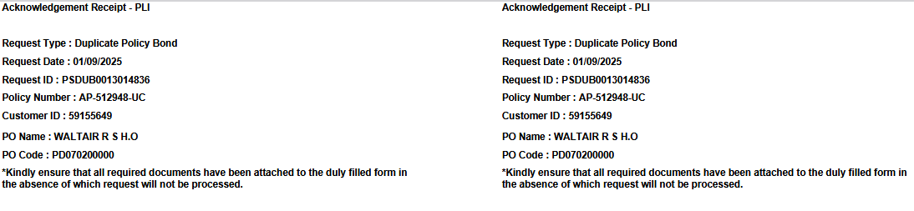

BILLING METHOD CHANGE
POLICY NUMBER-AP-589243-CC
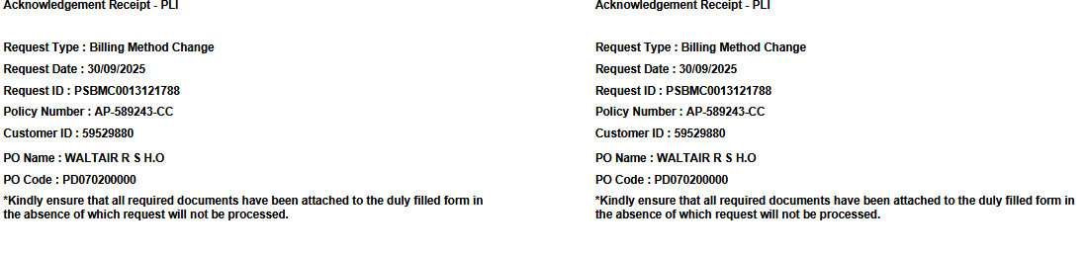

NOMINATION CHANGE
POLICY NUMBER-AP-584307-CS
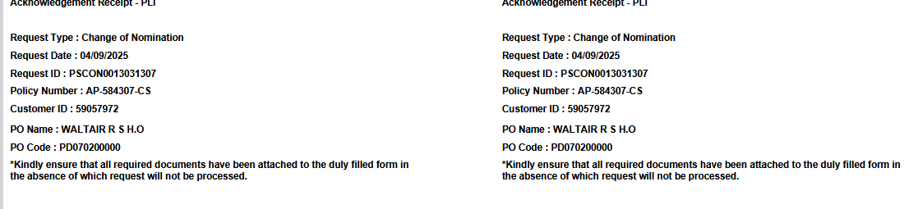

PREMIUM RECEIPTBOOK
POLICY NUMBER-0000012040494
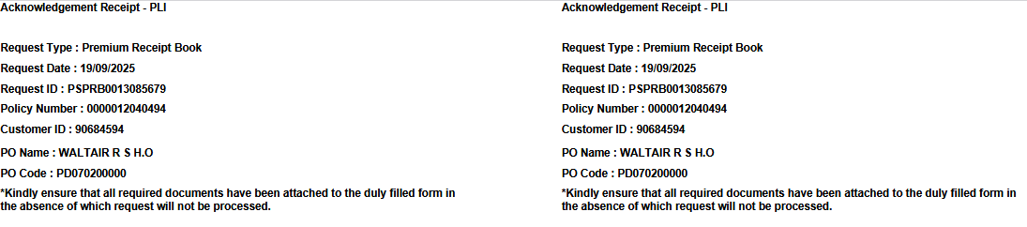

ADDRESS CHANGE

POLICY NUMBER-AP-511774-UC
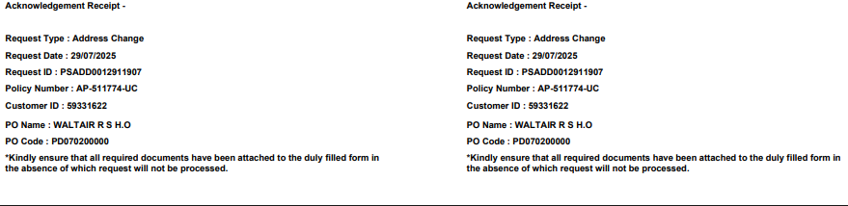

NAME CHANGE
POLICY NUMBER-0000000458382
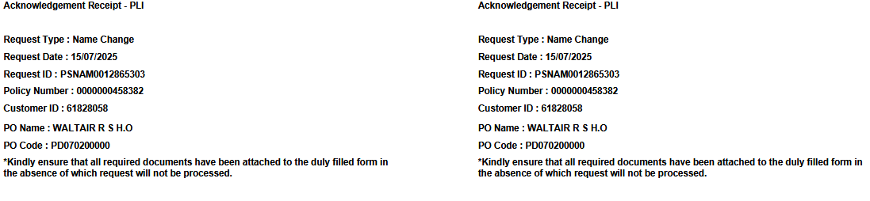

FREELOOK
POLICY NUMBER-0000012103934
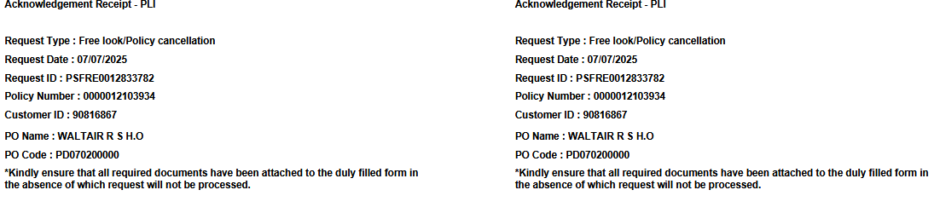

COMMUTATION
POLICY NUMBER-0000001916590
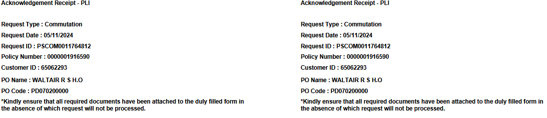

MATURITY
POLICY NUMBER- AP-439698-CS
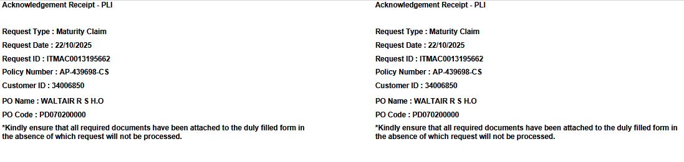

LOAN
POLICY NUMBER-0000001940091
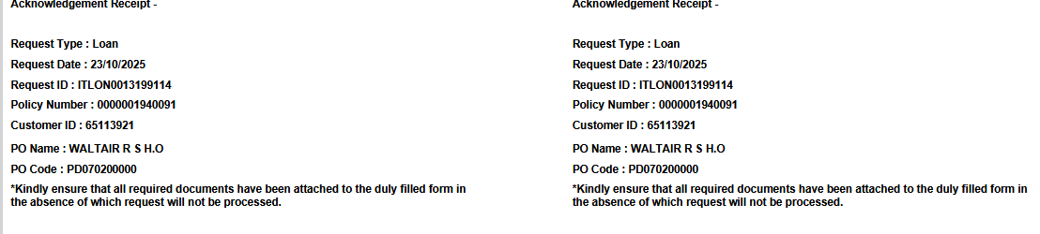

SURRENDER
POLICY NUMBER-AP-403856-UC
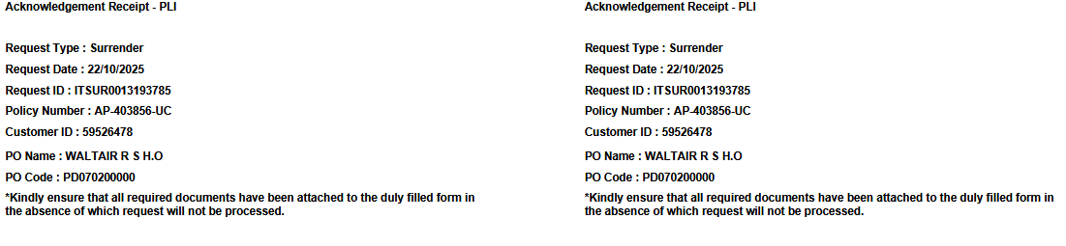

DEATH CLAIM
POLICY NUMBER-AP-419708-UC
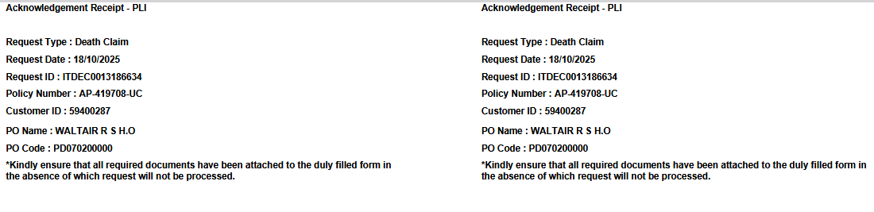

SURVIVAL
POLICY NUMBER-0000003126432

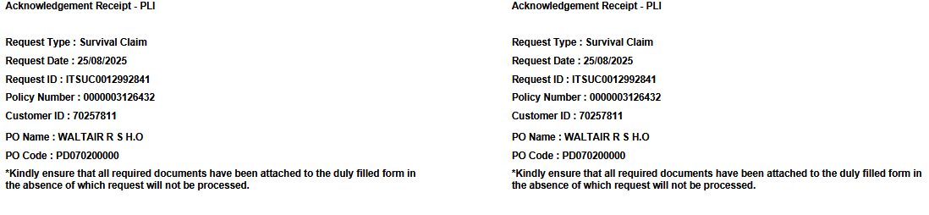

REVIVAL
POLICY NUMBER-AP-627201-CS
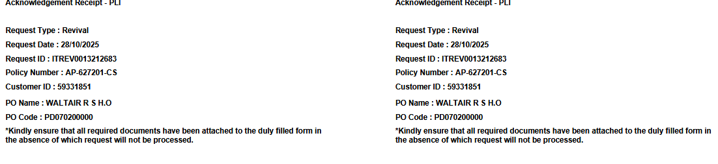

NEW PROPOSAL
POLICY NUMBER- 0000012786412
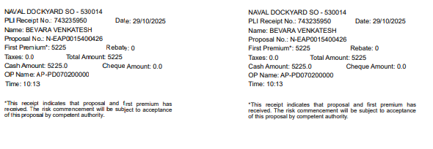

REDUCED PAIDUP
POLICY NUMBER-R-AP-VP-EA-156274
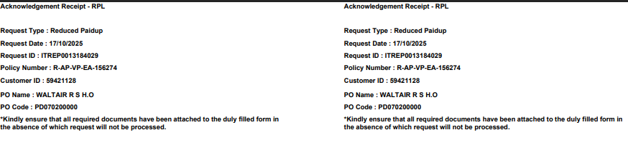

5. Attachments
The following documents can be referred.

